One popular use of logistic regression is to classify future observations as successes or failures based on measured characteristics. In addition to logistic regression there are many other ways to classify observations. Popular methods such as classification trees and support vector machines are inherently non-statistical and originated in the machine learning community. These newer approaches are not likelihood-based so they can't appeal to log-likelihood and AIC for model selection. Instead they rate models based on their classification accuracy, an approach that is called model calibration. Model calibration, for reasons that will be made clear below, is a good tool for assessing model performance, but is less useful as a way to select models. Model calibration methods can be used with logistic regression if we're willing to view our model as a way to classify observations as being either zeros or ones. If doing so does not make sense, then model calibration should not be used.

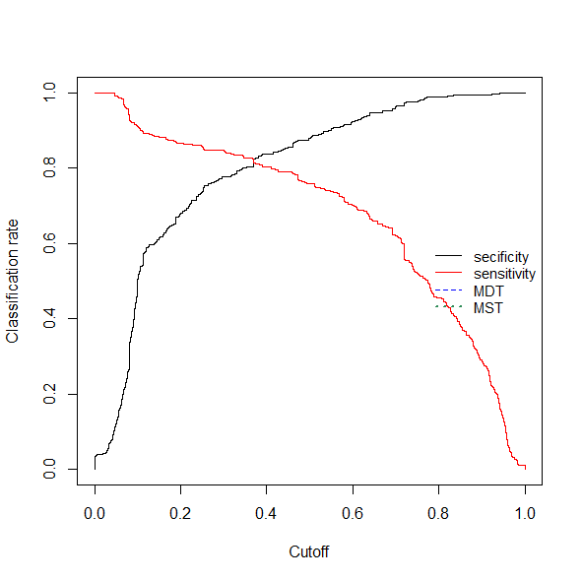

This graph shows the cutoff that makes the sensitivity = specificity for the logistic regression model of the Titanic data. Accuracy is .818. Cutoff value is .374.

This is an ROC curve which can be used to compare models.

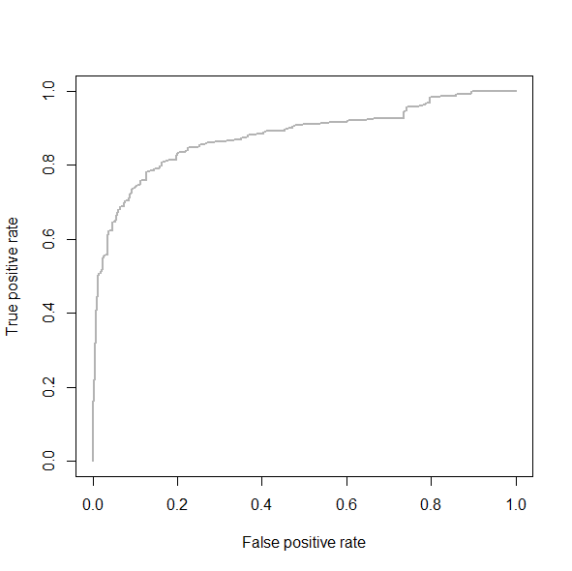

<http://www.unc.edu/courses/2010fall/ecol/563/001/docs/lectures/lecture21.htm>